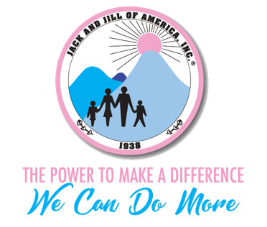
West Suburban Chicago Chapter
Five Star Chapter of Excellence
Committee Meeting Report
Program Year 2019-2020

Date: November 3, 2019

Purpose: Fundraiser Committee shall be responsible for the annual fundraising efforts for the chapter. They work in conjunction with the Foundation/Proposal Committee.

Committee Name: Fundraising Committee

Committee Chair: Nicole Fleming

Committee Members: Stephanie Cannon, Beatrice Lature, Simone Morton, Jaye Franklin, Natacha Ingram-Wigfall, Dawn Phillips, Betina Dunston-Johnson, Janene Marshall-Gatling, Tiffany Morgan, Monica Billinger, Stephanie Williams, Sanura Young, Melinda Stevens, Ami Morrison

Report:
In an informal meeting was held on 10/30/2019 with the chair and President Taylor met to discuss the results of the Survey that was giving in the chapter Meeting regarding the 2019 Jazzy Night Fundraiser. The following areas were discussed. :
VIP Experience
Silent Auction
NCAA

Contracts and vendors were reviewed and a timeline was set in place to contact and confirm each one.

Suggestions were discussed to help ease along areas such as the Registration process, Silent/Live Auction and VIP experience.

We will begin asking mothers at the November meeting to please bring wine and spirits for the Wine bar and the Liquor bar action items.

Recommendations/Information:
Based on the recommendations from the Survey a sign-up genius is being set up and will go live for mothers to sign up for silent Auction items.

The Sponsorship Package is being updated and will be available next week for distribution and placement on the website.

The save the date is being updated and the link to begin purchasing tickets will go live by the November Mothers meeting.

Committee Members in attendance:
Chair and President Taylor

Next scheduled Meeting:
The committee will be notified of a meeting to be held on 11/11/2019 at 8pm

