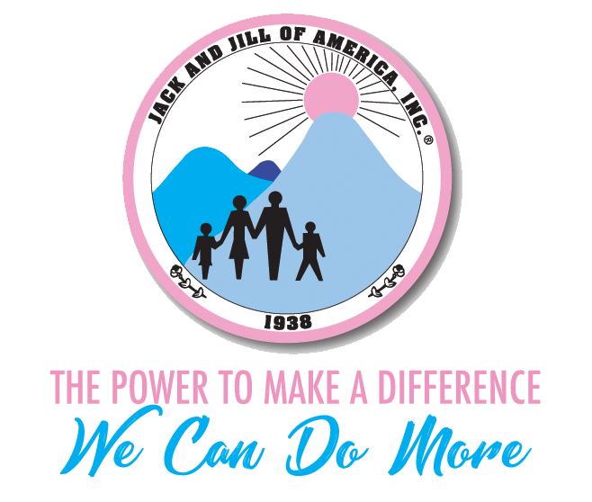
West Suburban Chicago Chapter
“Excellence and Impactful”

Five Star Chapter of Excellence

President’s Report
June 2019

Hello Mothers,

Welcome to the new program year! It’s always great to have the opportunity to start anew, fresh and eager to make this year better than the last. Given how well we did last year, I thought perhaps we will build on last year’s theme with a little additional message from our National President. This year’s theme is
“ Excellence and Impactful….. We Can Do More”

Let’s commit to doing more than what we achieved last year therefore making a bigger impact in our communities, with our children and our programming. I guess I could say we are “Taking it Higher” (sound familiar?).

June Planning Meeting is scheduled for June 15th, at DuPage AME Church from 8:30 am to 1:00pm, see you there!

Chapter Updates:
- Calendar at a Glance – VP Danley has complied all of our chapter events into one page. We will send this out and can be found of the chapter website.
- We are presenting our donation to the Diamond Youth Foundation on July 15 in Bolingbrook at 4:00pm. Please join us.
- Call in options- Please request call in information from me at least 3 days prior to our meeting. We will limit the number of call ins to 5 mothers so we will be sure we have a quorum.
- Committee Assignments for 2019-2020 will be completed at the June Chapter meeting.
- Communications – Please send any items you want to share with the chapter to CS Darey on or before the Sunday of the week you want it sent out. Everything sent out to the membership must be approved by the Chapter President. Remember personal information can be share on our private Facebook Page.
- If you are communicating with Regional or National Officers, it is proper to include the chapter president.
- Public Communications- The Chapter President is the official spokesperson for all chapter communications to the media, this includes, newspaper, magazines and social media. Please do not use the Jack and Jill of America, Inc. brand without permission. The National President is the official spokesperson for Jack and Jill.
- Chapter Superlatives were submitted on June 8 along with our Chapter check for Regional Conference.

Regional News:

Teen Leadership Conference: Volunteers needed particularly Dads. If your spouse is willing to help, send his contact information to me asap. We are also looking for a few more mothers to help the day of the Senior Gala. TLC is June 27 thru June 30 at Loyola University.

Regional Conference is July 10-14 in Cincinnati Ohio. VP Danley and I will represent the chapter as delegates. APD Wynn and Treasurer Williams will attend the Leadership Conference.

National News:

As “We Do More” over the summer, there is a summer reading list for our children as well as mothers. They are challenging every mother and child to read 12 books and share on social media. More detail will be share at the meeting.

On the Hill Summit registration is coming soon. It sells out within hours; therefore, it is important to be ready to register as soon as it is released. OTH is scheduled for Sept. 25-28.

Have a wonderful relaxing summer.

Yours in J&J Service,

Lori W . Taylor
President Taylor

