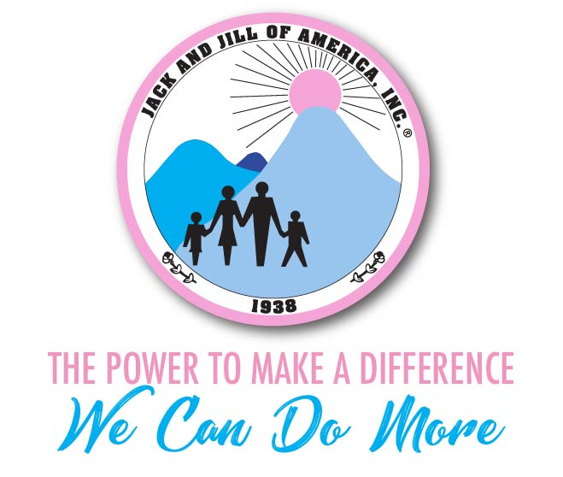
Jack and Jill of America, Incorporated
West Suburban Chicago Chapter
Post Office Box 9314, Naperville IL 60567
“Excellence and Impactful”

Committee Name: WSCC Jack and Jill Programming Committee Report

Purpose: To provide the programming report for June 2019

Committee Chair: Programming Director – Richelle Minor

Committee Members:
APD: Nikita Wynn
Grade Group Leaders:
Tiny Tots (Pre-School/K Gr)– Shautae Williams & TBD
Adventures( 1st -2nd Gr) -Melinda Alberty and Tiffany McQueen Lewis
Explorers (3rd-4th Gr) – Ami Morrison and Dawn Phillips
Pathfinders (5-6th Gr) Beverly Falls and Beatrice Lauture
Navigators (7-8th Gr) Leslie Edwards and Chandra Wiggs
Trailblazers (9-12th Gr) LTA Tiffany Morgan: Teen Advisors: Helen Austin, Teressa Skeete, Angela Patterson, Sonya Griffin

Medical Release Forms:
- Medical Release forms were distributed to all mothers for signature. All medical release forms are complete. All forms are stored with restrictions on drop box for 2019-2020.

Programming Planning Committee Meeting June 15:

The Programming Planning meeting was held with all Mothers to begin planning the 2019-2020 grade group activities. The following items were reviewed:
- Goals for this Programming Year:
  - Community Service: All WSCC Youth to turn in volunteer hours. Goal is to have all children obtain 25 hours.
  - Plan the program year by “thinking out of the box” and being AMAZING!
  - Leadership Modules will be tracked and monitored.
  - October and March “themes” were exchanged. October is now “Civic/Legislative” and March is now STEAM.
- Programming Requirements for Monthly Activities was reviewed by APD Wynn
- Folders that included the new activity form and community service hour requirements were provided to Mothers.
- Programming Activity Forms: All grade groups were required to plan activities with a short description. All activity forms were due no later than July 15. All activities have been stored on drop box.
- Surveys: Survey information was collected from mothers pertaining to ideas for 2019-2020 activities (picnic, MLK day of Service and Black Family Day)

Programming Activities:
- June Activity forms have been submitted and stored on dropbox.
- Jack and Jill Day/HBCU/Carole Roberson Day – Sept 14:
  - Jack and Jill Day/Carole Roberson day will be celebrated with the Region held on September 14. The Chapter (WSCC) Picnic was scheduled on September 7 but was canceled to participate with the Region. The region is expecting 50% participation. Currently 23 mothers are signed up to attend. Attendance will be taken during this event.
  - T-Shirts were ordered for all Mother’s within the Chapter.
  - The request is all mothers wear their Jack and Jill Chapter T-Shirts at the Classic on Sept. 14.
- Trailblazers: Planning Session held on 8/24 where the teams planned their upcoming activities.

- Programming Activity Dates and Committees:
- Chapter Picnic/Jack and Jill Day - Sept 7 (Consolidated with HBCU Game on Sept 14)
      - Location: Park from last year in Wheaton
      - Committee Members:
        - Beverly Falls
        - Sonya Griffin
        - Beatrice Lauture
- HBCU Game - Sept 14 (Hampton versus Howard)
      - Committee Members:
        - Tiffany McQueen
        - Angela Patterson
        - Note: The E-Board will be discussing this further.
    - On The Hill – Washington DC (Teens)
      - September 25-29
- MLK Day - Jan 20
      - Committee Members:
        - Tiffany Morgan
        - Dawn Phillips
        - Ami Morrison
- Father Appreciation – April (Date TBD)
      - Committee Members:
        - Shuntae Williams
        - Chandra Wiggs
        - Melinda Alberty
- Black Family Day - May 3, 2020
      - Committee Members:
        - Teressa Skeete
        - Leslie Edwards
        - Helen Crawley

Next Programming Meeting (Committee Meeting):
- October 4th (Tentative) at 8:30 p.m. CT

