Five Star Chapter of Excellence
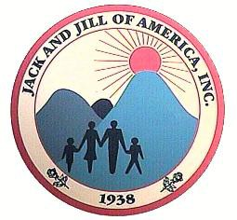

Jack & Jill of America, Inc.

West Suburban Chicago Chapter

Financial Secretary Report

2018-2019 Program Year

Date: June 7, 2019

Committee Name: Financial Secretary

Purpose:
Collect chapter funds
Maintain a record of collections
Provide receipts of those collections
Record and Transfer funds collected to the Chapter Treasurer

Report:

OPERATING: Funds Collected 5.7.2019 to 6.6.2019

(2018-2019 Program Year)
Misc. Underpayments Due to Paypal fees. | $41.84
TLC Payments | $3,081.88
TLC Bus Payments | $641.60
LOA Payments ( inclusive of LOA Fee/National/Regional) | $495.00
Jacket Payment | $46.00
Operating: Total Funds Collected/Transferred | $4,306.32

FUNDRAISING: Funds Collected/Transferred 5.7.2019 to 6.6.2019

(2018-2019 Program Year)
Fundraising : Total Funds Collected/Transferred | $0.00

Best Practice Recommendations:
- Please maintain correspondence sent to you in regards to “Financial obligations, amount(s) requested and due dates”, so that you have them for future reference.
- Please submit exact amounts for payments. Overpayments will not be refunded.
- Please email the Financial Secretary should you have any questions or concerns.
- Avoid waiting to the last minute to pay if possible.

Upcoming Financial Due Dates:

JULY 15th – Chapter Dues are Due
JULY 16th - Chapter Dues are Late add $20.00
JULY 31st – Last day to Pay Chapter Dues with Late fee and Maintain Good Membership Standing.

SEPTEMBER 1 – National and Regional Dues are Due – NO GRACE PERIOD

Respectfully Submitted by:

Nicole Fleming
Financial Secretary
WSCC of Jack & Jill of America, Incorporated

